Whole Foods Market UX Report

Jingwen Wang
Arizona State University
ENG302: Business Writing
Paulette Stevenson
January 25, 2023

Introduction
The supermarket is an essential element in every family's life. It's fair to say that the supermarket is more important to the family than the TV or some furniture. Supermarkets fully meet the basic needs of human survival. With the rapid economic development, there are more and more choices in supermarkets. Every supermarket has a distinct character and different supermarkets have different symbolic meanings for each customer.. Whole Food Market(WFM) is an organic food supermarket that many families go to. It's famous for selling organic food because it uses organic as a label and it becomes a very visible and distinctive symbol of the brand. I noticed WFM at first because its name was very pertinent. In this user report I will proceed with these questions: How did they see the business opportunity in organic food? Why do they think it will be accepted by consumers? Do they have any plans to focus not just on organic food, but experiment with other foods as well? What, if anything, will be the biggest obstacle? If not, why not?

Methods
- How to study the user experience
- Website function analysis
- Offline stores function analysis
- Yelp customers feedback analysis

- Analysis details
Firstly, the official website of WFM is analyzed in detail. The front page of the website features the largest section of the WFM video promotion during this period, with links to details of the event. Food promotions remain prominent as the site slides down. But instead of advertising as usual, WFM has thoughtfully placed some recipes where viewers can see them directly. Ordering links are also placed for in-store hot food orders, as well as delivery services. Then there is the philosophy of WFM and related promotional activities. Some links to basic WFM information or customer service buttons are placed at the top and bottom of the homepage, respectively.
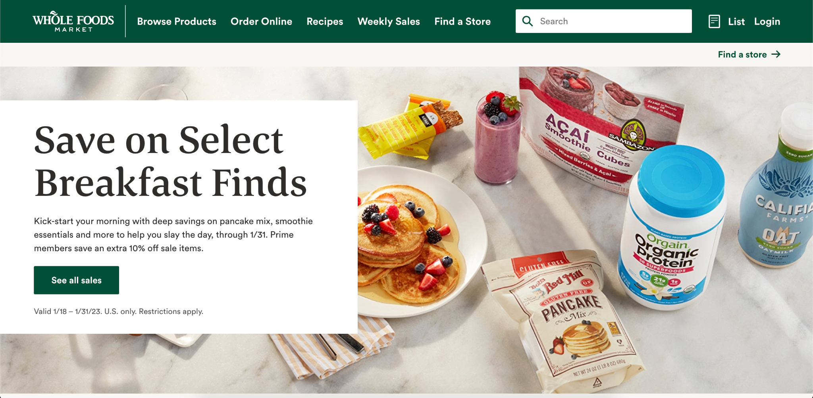

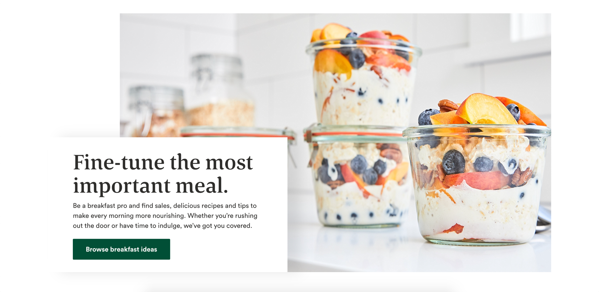
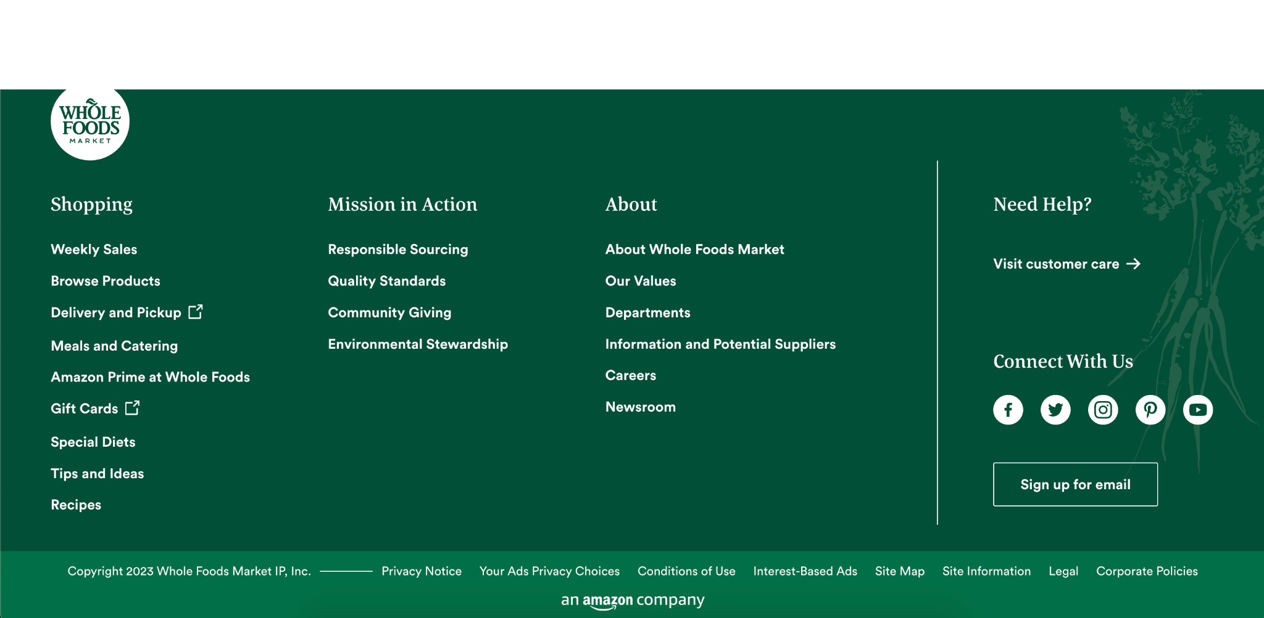
And a Google search of nearby WFM information will be accompanied by a link to a specific website that is specific to that particular WFM. The website shows in great detail what sales the WFM is having this week, as well as features the store has, such as custom flower arrangements, grocery pickup, custom cakes, Amazon returns, and more.
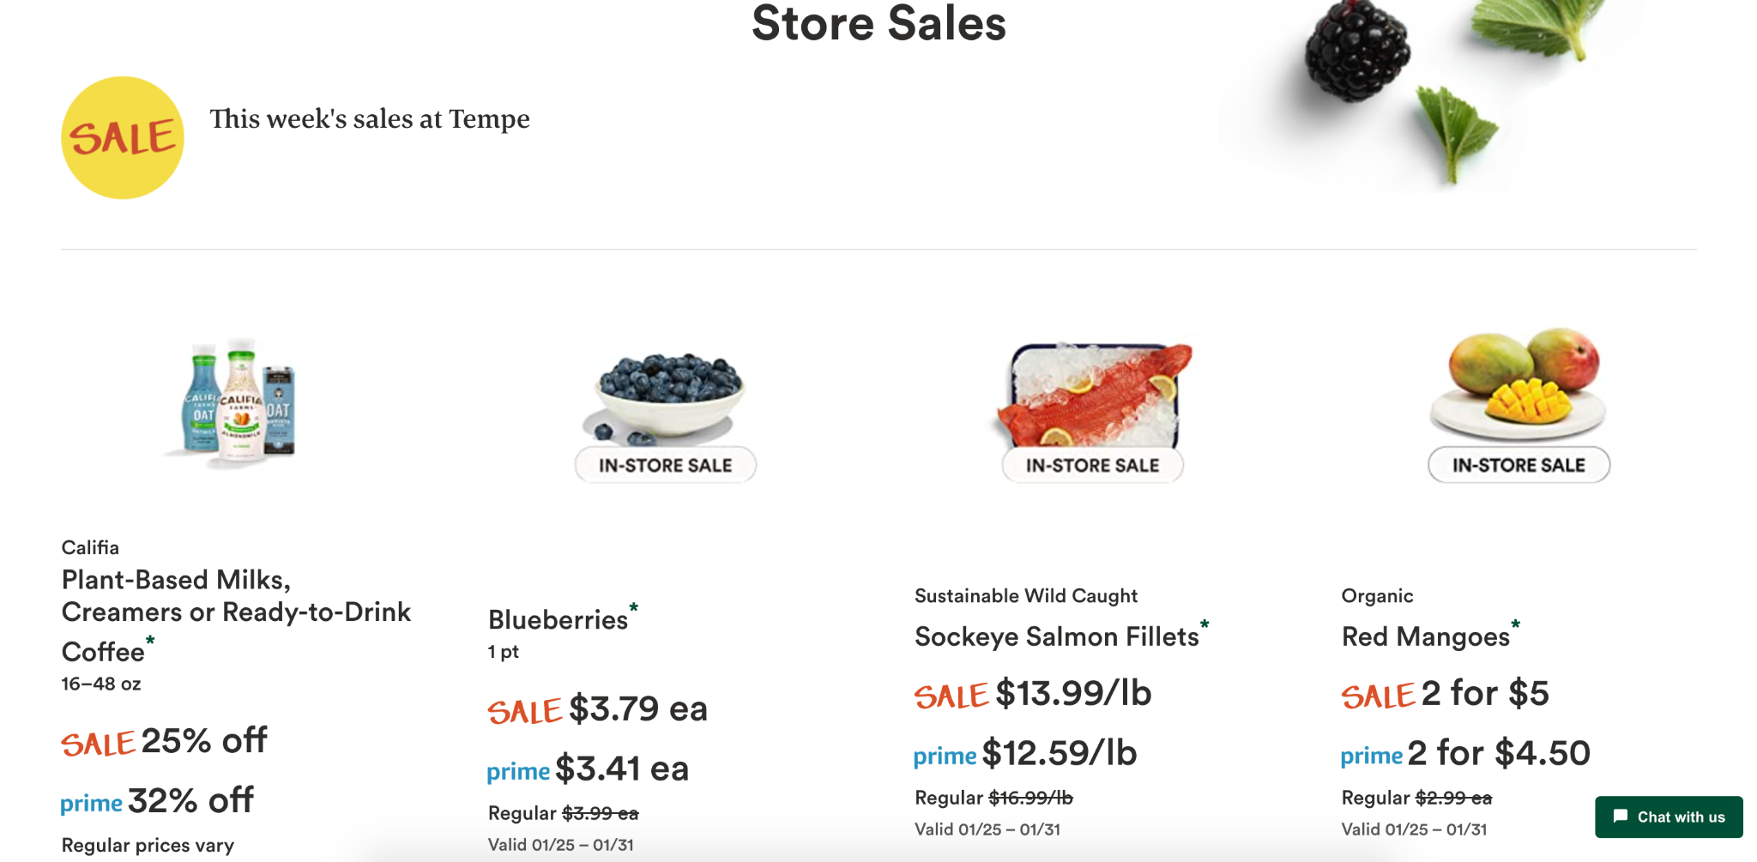
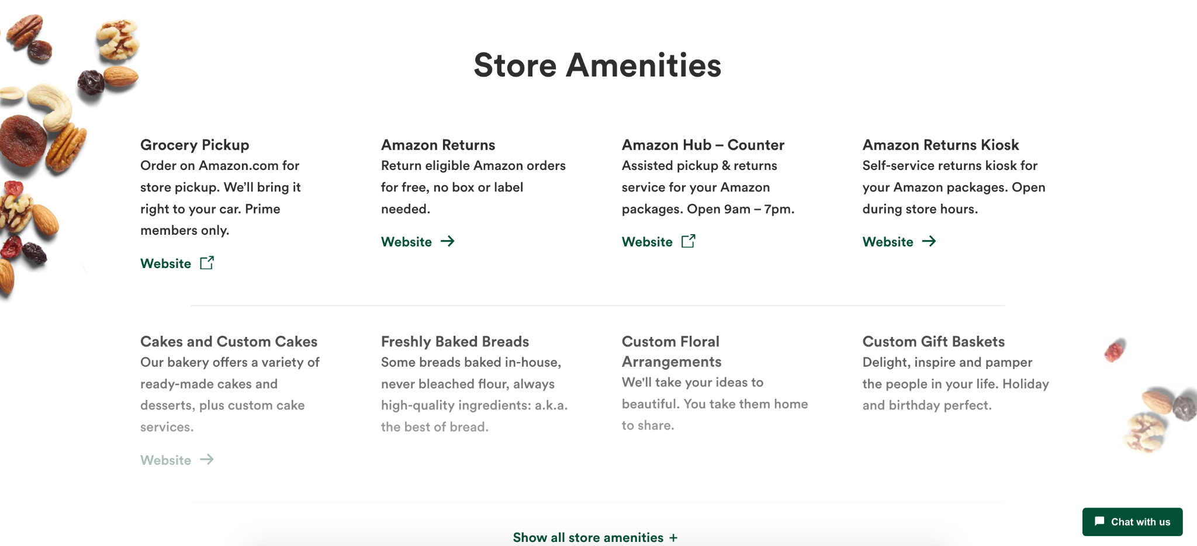

Secondly, the real investigation of offline stores. The supermarket placed shopping carts and baskets at the entrance. The shopping area at the entrance displays fresh fruits and flowers, followed by vegetables and fresh meat. Further in is some custard, some fridge food. There are also kitchen dressings, snacks, frozen foods and kitchen tools. And finally some ready-to-eat and hot foods. There are many waiters at each hot food counter to help, as well as the raw meat counter, the flower arrangement counter and the fresh drinks counter. There is also a parking lot outside the store for guests to park and bike storage for those who arrive on bikes. At the end of the checkout, a select group of employees offer to pack. There is also a bar on the second floor for customers to use. Guests with shopping carts can use escalators to bring their carts to the second floor.

Finally, customer reviews on yelp. Customer reviews are mixed. Most people's comments on WFM start with the advantages. For example, many people say that the food in this supermarket is very fresh and the shopping experience is very smooth and convenient. Secondly, some people will point out that this supermarket is different from other supermarkets, such as its small scale and the products are not complete. This is different for different people, some people think it is a weakness but others think it is a strength, because it is more relevant to daily life. The three and a half stars on yelp show that most customers' reviews of WFM are above average.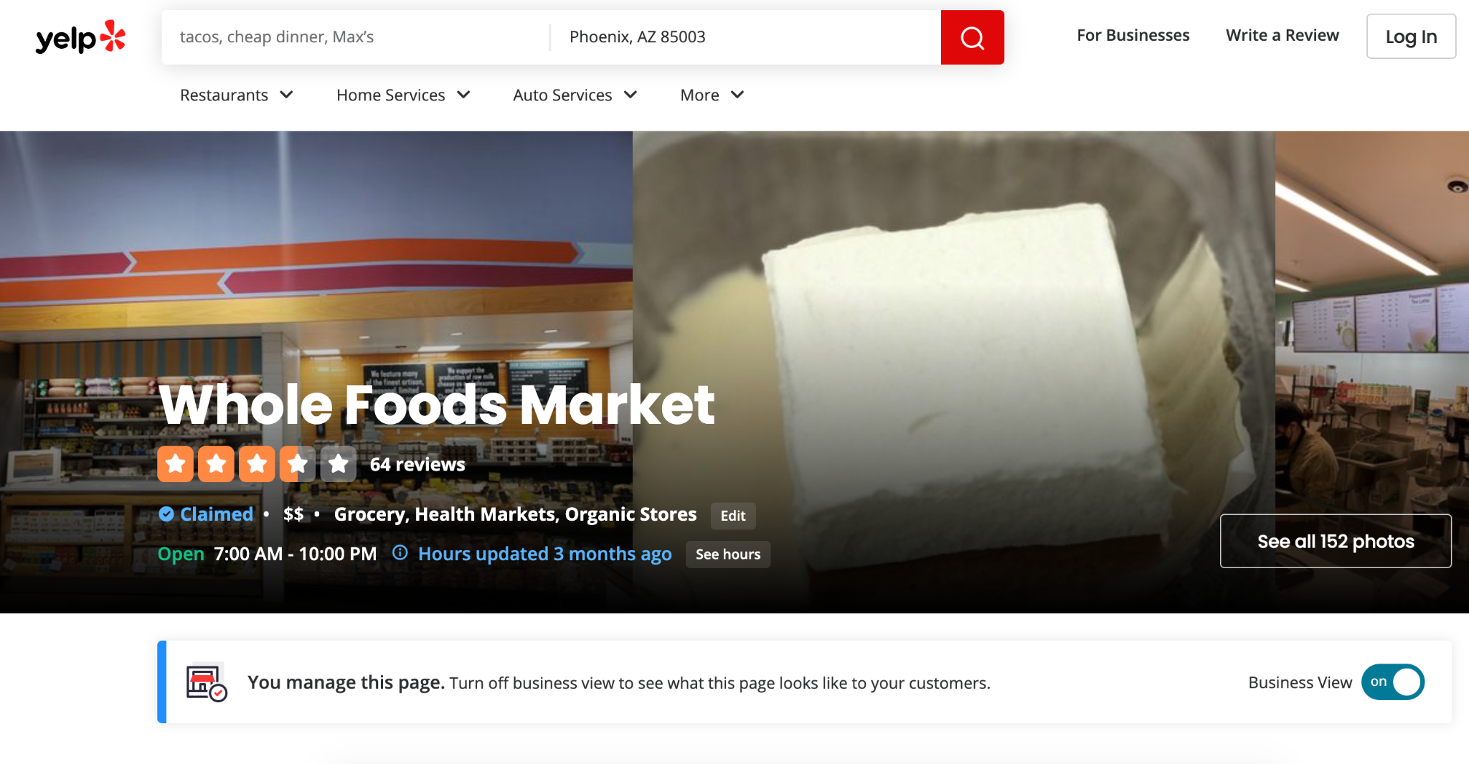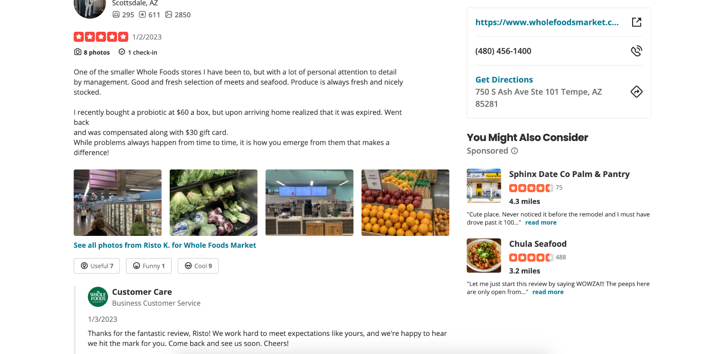

Results
- Content structure
- Website experience analysis results
- Offline store experience analysis results
- Yelp feedback analysis results

Compared to the WFM concept of supermarkets, the design of the site is very reasonable and effective for visitors. The site does not list its organic slogan on its front page, nor does it highlight how well it has done so far. Instead, they display their commitment to their customers in the most prominent section. Many excellent organizations or companies will choose to list their excellent achievements on the website in a prominent place to attract more audience groups, because people tend to be attracted by strong and excellent enterprises. But WFM's website is the most direct and simple way to show the most relevant care for consumers.

The offline store also continues WFM's concept of putting customer experience first in website design. First of all, offline stores attach great importance to customer experience. Flowers and fresh fruit placed at the door can effectively promote the sense of pleasure and happiness of customers. It's very clear what to do with organic and non-organic food. One type of food is grouped together, but organic and non-organic are clearly distinguished. The waiters in the raw meat counter effectively protect the quality and hygienic environment of the meat, and it is more convenient and fast for customers to buy it, and the same is true in the hot food counter. There are always attendants walking around the shopping area to answer any questions that arise during the purchase process. At the end of the checkout process, each counter has a special employee who packs the goods, and each package comes with two bags instead of one. This completely reflects the degree of caring for customers of WFM.

Yelp reviews are generally very pertinent. Customers can directly feel the convenience brought by WFM and feel that these conveniences are very helpful to the quality of physical life. At the same time, we will also find the problems that need to be improved in WFM, such as the service attitude is not very uniform, the quality of goods is good and bad, and so on. Representatives for WFM responded directly to the comments. In the face of praise from customers, remain grateful and continue to work hard. In the face of criticism, remain sorry and correct the attitude.

Discussion
WFM does a great job of being organic and caring for their customers. According to their concept of development, perhaps organic food is only a small part, they are more committed to a more perfect integration of nature and human food, it's a great project and a challenging adventure. This is WFM's view of the world. For customers in daily life, they maintain strict control of product quality, provide multi-functional comprehensive services and always put customer experience first place.


Based on the level of detail for reviews on Yelp, the overall level of WFM is good. In response to the public's comments, I would like to express some of my true feelings. My first impression of WFM was that it was clean and organized. They have done a good job in the layout of the store, which can be very effective in attracting customers compared to some smelly and cluttered supermarkets. The merchandise section of the store is also clear, with similar types of items grouped together. Secondly, in my opinion, WFM is more suitable for families living alone or with two or three people. The items are sold in small units, which is a big difference from big stores like Target or Costco. But for that reason, WFMS are far more sophisticated than the larger stores. It is also easier to win the favor of customers. Also, WFM's organic food brand is very well done. People pay more and more attention to health, so healthy food is taking more and more part in daily life. WFM does put organic food at the forefront of its sales, with both organic and non-organic versions of most of the food in the store. WFM has 22,000 organic products in its inventory, according to its website. So overall, I think the experience of WFM is excellent, and it's a store worth visiting.

Conclusion
This report mainly shows the data surveys of Whole Foods Market. The report first introduces the research topic of WFM from the basic introduction, then shows the research methods, then describes the detailed content of the research, and finally carries out objective and subjective discussion. Through this user survey. It can be found that Whole Foods Market is an excellent brand supermarket with potential. But it also means they have more room for improvement. To sum up, Whole Foods Market may not be fully perfect, however, they are appealing and convenient for users and consumers.

Reference

Whatever makes you whole. Whole Foods Market. (n.d.). Retrieved January 20, 2023, from https://www.wholefoodsmarket.com/
Whole foods market - tempe, AZ. Yelp. (n.d.). Retrieved January 20, 2023, from https://www.yelp.com/biz/whole-foods-market-tempe-3

